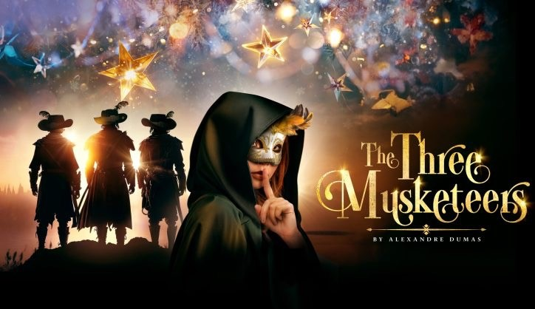

Welcome to the New Vic Theatre!
We want all our audiences to feel comfortable at the New Vic Theatre. We know that some audience members prefer to know details about the venue and the production in advance.
We’ve created this visual information pack with some extra information about what you can expect when you visit the New Vic Theatre. It also contains a story summary and a breakdown of the lights, sounds and dramatic moments you might experience in
The Three Musketeers.



This is a performance at the New Vic Theatre. It is performed in-the-round which means the audience sits in a circle around the actors.

This production is a play. It is an adaptation of the famous book The Three Musketeers written by Alexandre Dumas. It follows the characters of d’Artagnan and Milady as they seek to make their fortune in the Big City.
This production is a family show and is suitable for everyone of all ages.

The play is split into two parts called ‘Acts’. Act 1 is about 55 minutes long. After Act 1 there is a 20-minute break called an interval. This is where you can go to the toilet or get a drink from the café. Act 2 is about 55 minutes long.

There are often lots of people watching the performance. When you arrive at the theatre, it can feel quite busy. There will be members of staff on hand to help you if you need any assistance.

You can spot members of staff because they may be wearing lanyards that look like this.


There will be an announcement to tell you when to take your seat inside the theatre. There will be members of staff available to help you find your seat.
When the performance starts, the lights in the theatre will fade down. It gets quite dark at moments during the play, but never for a long time.





The play has a musical underscore. There are some moments where this can feel quite loud, especially during the fights. Please do wear ear protection if it will make you more comfortable.
During the play, there are some very dramatic fights. Some of these use swords and daggers which look real and make sharp metallic sounds. It can be a little bit frightening, but the actors have practiced to make them look this way! The actors are all safe, and you will be safe in the audience too.
There are lots of different coloured lights used in the production. Because the set is so shiny, it can sometimes feel very bright! Sometimes there are lights that have special effects that move or wobble.
During this production, we use flaming torches to help create a nighttime atmosphere. Actors enter the stage from the aisles carrying these torches. If you need to exit the auditorium during the show, make sure you double check up the aisle and allow any actors to pass first!



If you need to leave the theatre and find a quiet space, we support you. Members of staff will be available to assist you in exiting the auditorium and finding a suitable space.


When the play finishes, the performers will all return to the stage to take a bow. You will see they are often smiling at you to reassure you that they are no longer in character.
They love to hear you have enjoyed the performance!
Please do clap and cheer if you enjoyed it.
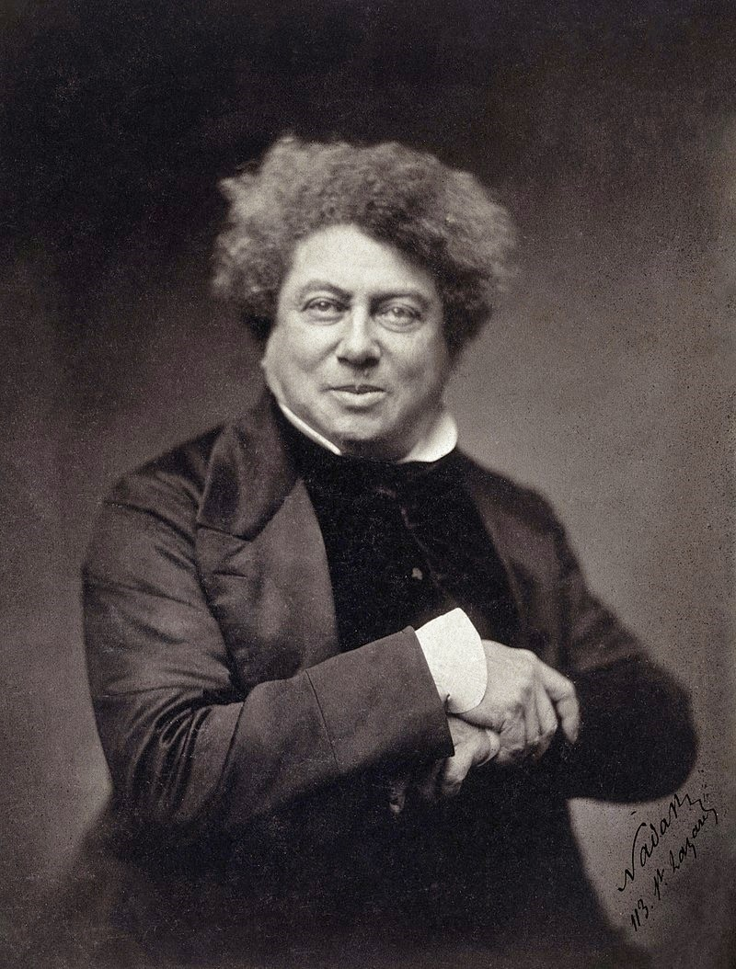
Our production is based on a story written by a French author called Alexandre Dumas. He wrote the book in 1844 which was just after the French Revolution. This was a period in history where the French people threw out the monarchy to become a Republic. Dumas’s story is set in 1620s, a century before the French Revolution.
However, when making our production we have tried to create an action-adventure movie on stage and not a period drama. This is why some of the characters are in slightly more modern looking clothes.
Alexandre Dumas’s original novel is set in France, in
Paris. D’Artagnan is from Gascony, a province to the South-West of Paris. In our production, we kept the same locations but chosen UK accents to reflect this geography. Milady has a cockney accent and D’Artagnan a West Country one.
The set design is based on the Great Hall of Mirrors at the Palace of Versailles. This is a huge royal palace that was built in Paris in 1631.
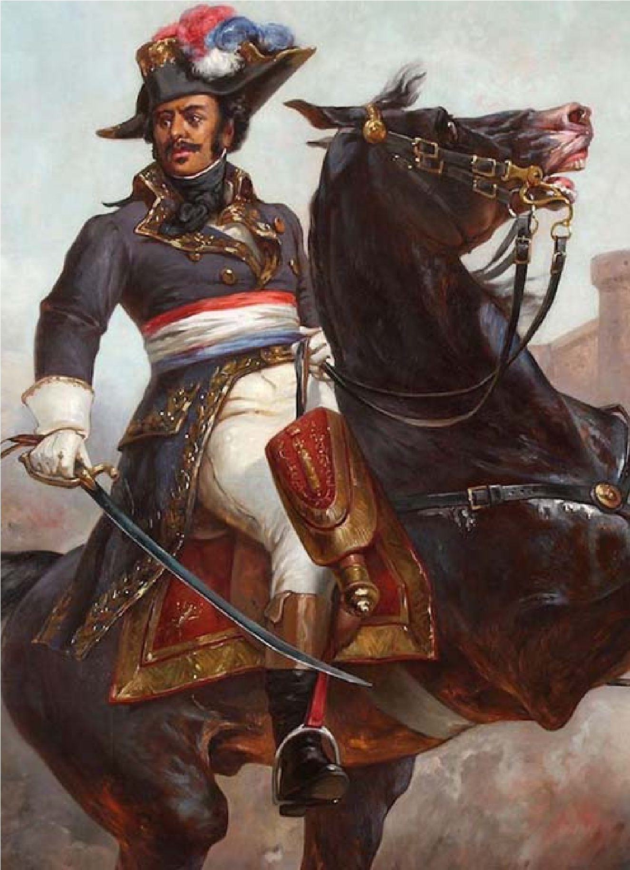
Alexandre Dumas took much inspiration from his father’s life when writing his novels.
Thomas Dumas had been born into slavery in what is now Haiti, at that time a French colony. His mother was an enslaved woman of African heritage, and his father was a French nobleman who owned her. After a fifteen-year relationship, during which they had several children, the nobleman returned to France to claim his inherited land and title. He sold the mother of his children and their daughters. He took their son Thomas with him.
Slavery had been abolished in France in 1315, so the moment Thomas arrived there, he became free. However, as an
illegitimate child he could not live the life of a nobleman. He joined the military instead - as a private rather than as a commissioned officer like his peers. As a Dragoon, he proved himself fearless and extraordinary. His rise was impressive, and at the age of 31 he became the youngest ever General in the French army.
He acted as riot police in Paris during the French Revolution, defended the alps, clashed with Bonaparte (who was to re-legitimise slavery in France), was imprisoned in Spain, and expressed strong views about freedom and equality. Thomas was a hero to his nation. His statue was raised up in Paris. It no longer exists as it was melted down by the Nazis in WW2.
Thomas died when his own child was only three years old. Nevertheless, to his son Alexandre he was a hero. Many of the author’s most famous literary characters were inspired by his father. Their surname Dumas is French but it’s not that of the nobleman.

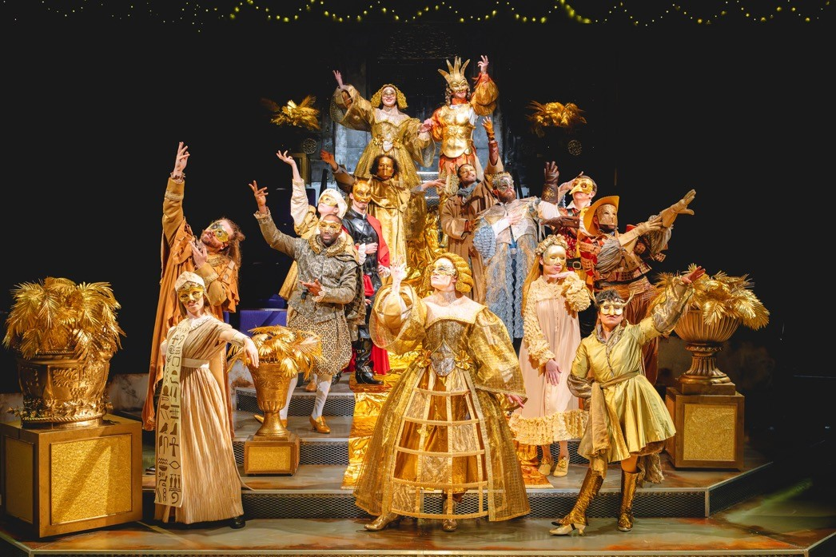
Who is Who…
D’Artagnan (dar-tan-yan) is a country bumpkin who has a dream of becoming a Musketeer and guarding the Queen. He leaves his home on the farm to head to the big city, where the streets are paved with gold.
Athos (a-thos), Porthos (por-thos) and Aramis (a-ra-mis) are the famous Three Musketeers. Musketeers are a special regiment in the French army. They serve as the Royal Guard and are there to protect the King and Queen – a little like MI6!
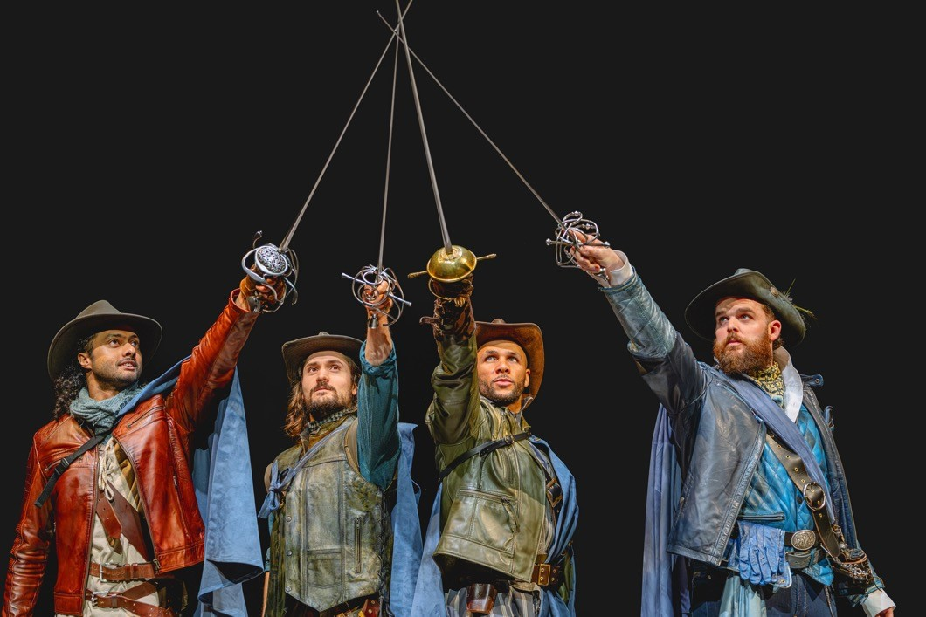
The Cardinal is the chief advisor to the King and Queen.
Milady, or Lucy, starts the play as a servant. Like D’Artagnan, she is looking for a way to better her circumstances and follow her dreams. But she does go about it in a dishonourable way…
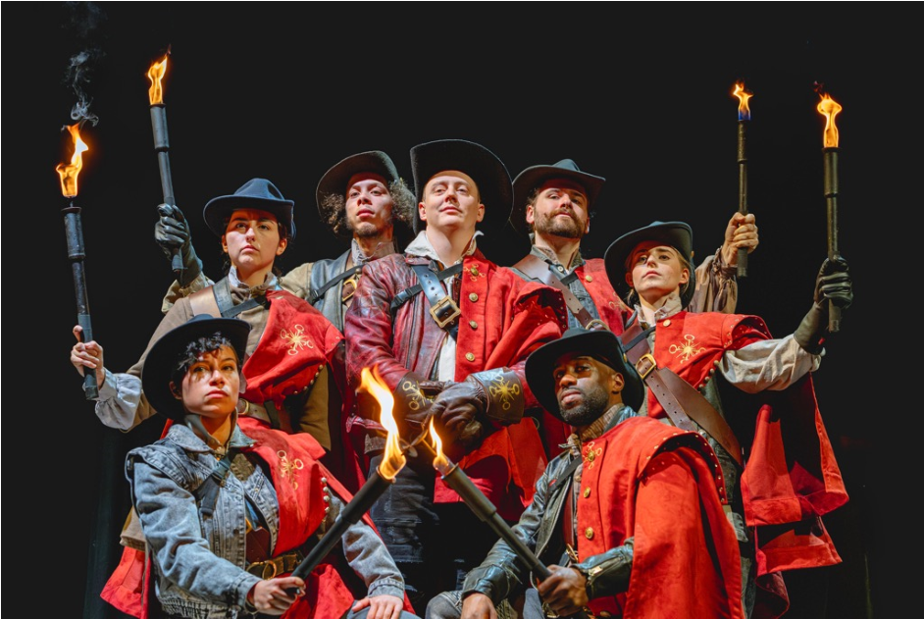
The King and Queen are two very pompous, silly individuals who are out of touch with the people they govern. They love the finer things in life and often waste money on things like gold and jewellery, and not on the people.
Constance is the Queen’s chief Lady in Waiting – while she is there to serve, she is also a confidante.
The Captain oversees the City Guard. He answers to the Cardinal. At the start of the play, their responsibilities are to Guard the city streets.

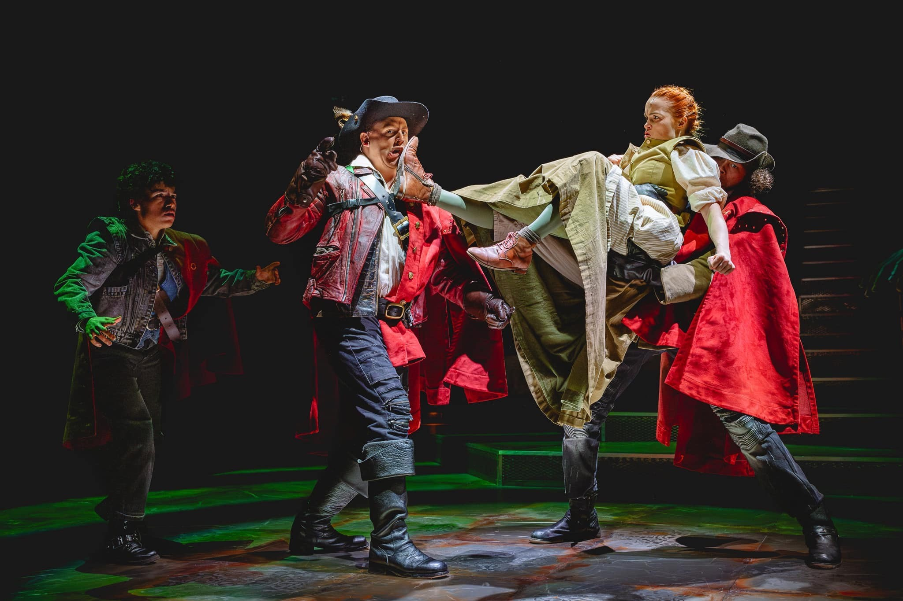
Plot Summary Act 1
The play begins with D’Artagnan at home in the countryside and Lucy scrubbing steps in the big city. Both resolve to turn their dreams into reality – D’Artagnan by travelling to the big city to become a Royal Guard, and Lucy by stealing the silverware to trade for money.
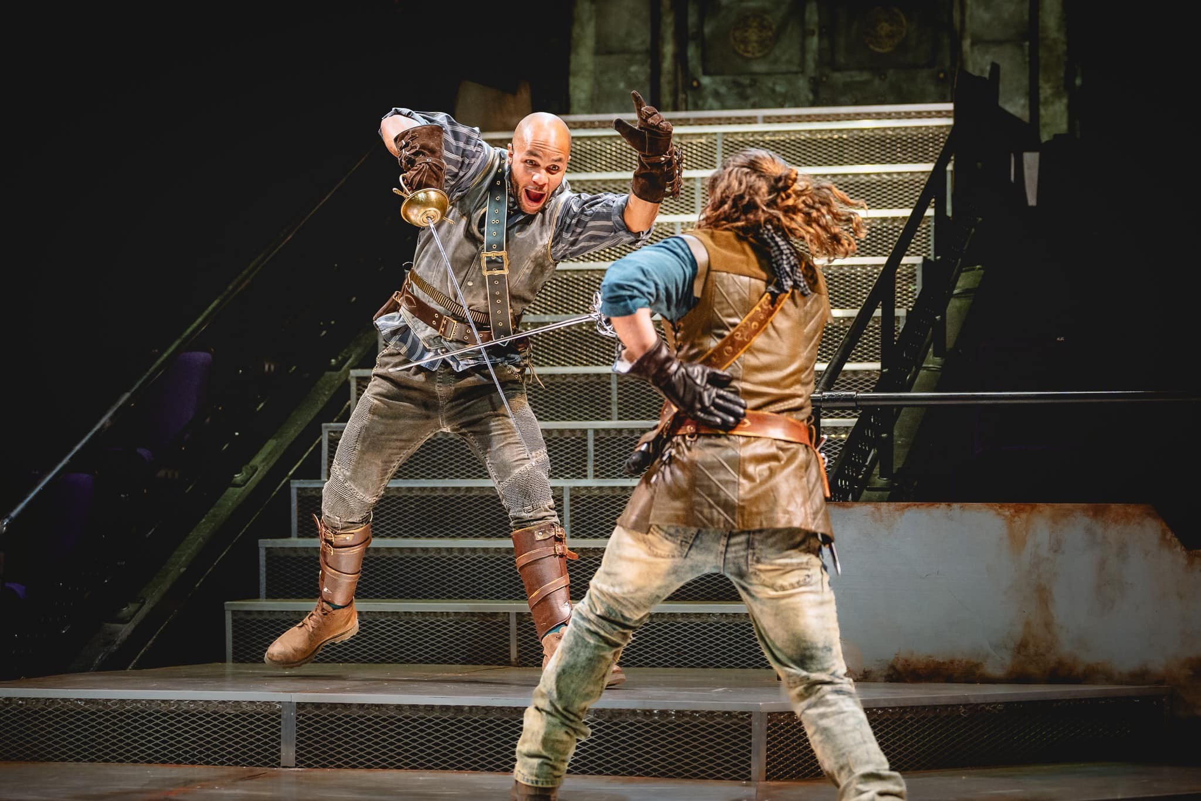
Lucy is chased by the City Guard but discovers her amazing fight skills. She bumps into D’Artagnan who offers her a hand up and calls her Milady. Milady escapes. The Cardinal enters and criticises his Guard for being useless. He offers Lucy a job working for him in return for a reward.
In the next scene, D’Artagnan meets Athos, Porthos and Aramis who are practicing their fight skills on the Palace steps. He impresses them by beating them in a duel. The Cardinal enters with the Queen who is being interviewed. She gives the Cardinal her diamond necklace to put back in the safe, and he hands it to Athos. Constance, arrives and takes the necklace. D’Artagnan falls in love at first sight. The Musketeers tell D’artagnan in order to be a Royal Guard, he must start with the Night Watch.
The Captain enters and gives D’Artagnan a rattle to be used in emergencies on the Night Watch. He’s not very good at it – he lets a disguised Aramis and Constance pass. Milady enters and when D’Artagnan tries to stop her passing into the palace, she knocks him out.

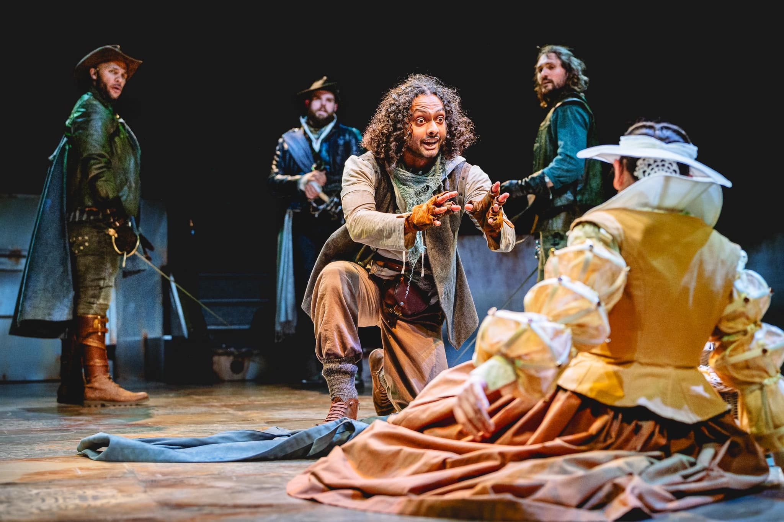
Plot Summary Act 1 continues…
D’Artagnan awakes to find himself surrounded by the Musketeers who are all very disappointed in him for sleeping on the job. They take him to the park and give him some training. Constance brings a picnic, but they are interrupted by a scream from the palace.
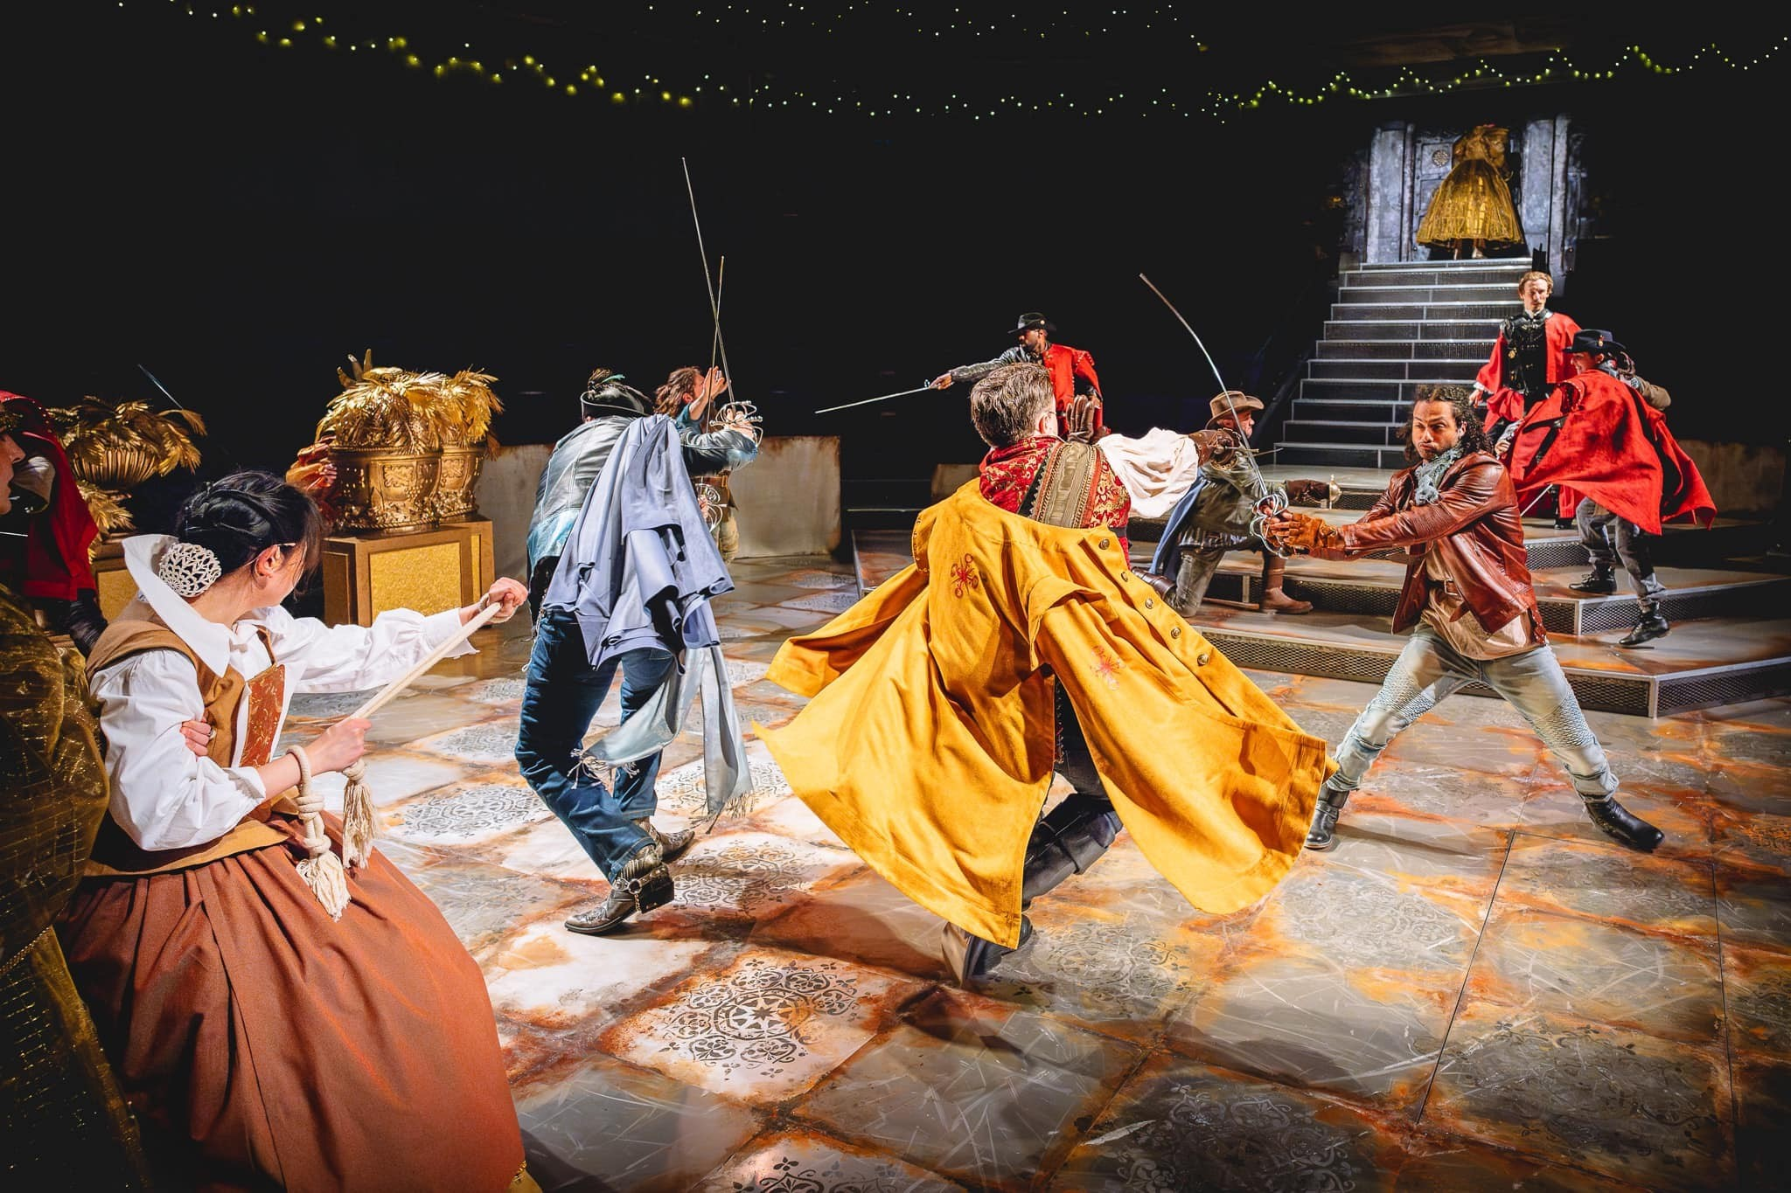
When they arrive, the Queen is distraught because she can’t find the diamond necklace. The Cardinal arrives and invites everyone to cast their minds back. They rewind to the interview the Queen had with the reporter and realise the Cardinal deduces that Athos was the last to be seen with the necklace. He places him under arrest.
Athos is revealed to be a Count. Porthos is upset that Athos lied about his noble origins but agrees to fight to to defend his honour. D’Artagnan chooses to fight with the Musketeers. A big battle with the City Guard ensues. The Musketeers agree to split up and meet at the sign of the Fleur de Lys.

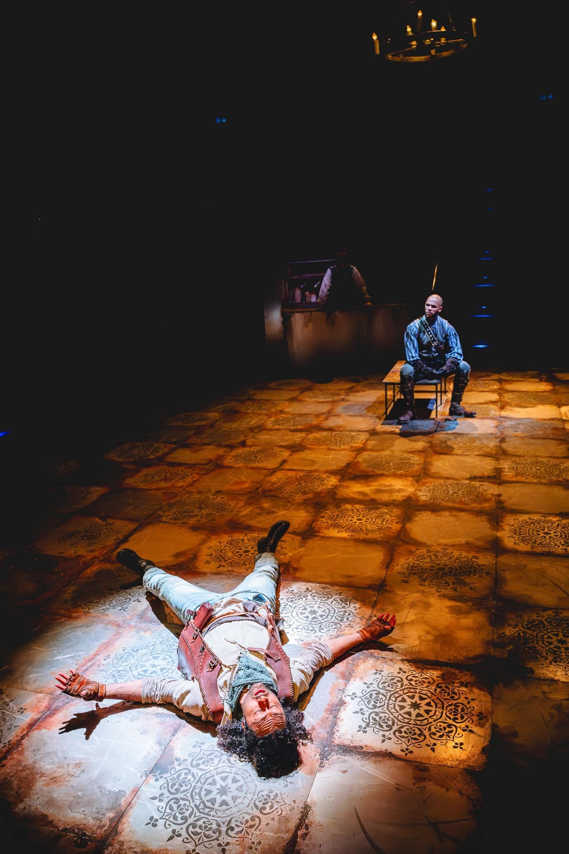
Plot Summary Act 2
Disguised as a Washerwoman, Aramis tries to gain entry to the Fleur de arrive, but the grumpy Innkeeper makes him wait until he’s checked the password. Porthos and D’Artagnan arrive, and they try to ram the door of the inn open. Inside they discover Athos.
Aramis hypnotises D’Artagnan and tries to encourage him to remember who knocked him out on the Night Watch. D’Artagnan replays his memory and realises it was Milady.
In the next scene, the Cardinal has appointed Milady as a Lady in Waiting. He lets Constance know they plan to hang the Musketeers when they catch them. Constance is upset, and Milady uses it as an opportunity to kidnap her.
As the City Guard patrol outside the palace, the Musketeers hatch a plan to break back into the palace. First of all, Athos reveals his history as the son of a noble man and a slave woman, reminding Porthos that there are some parts of his past that he does not wish to share. They make friends again, and plot how they will enter the palace.
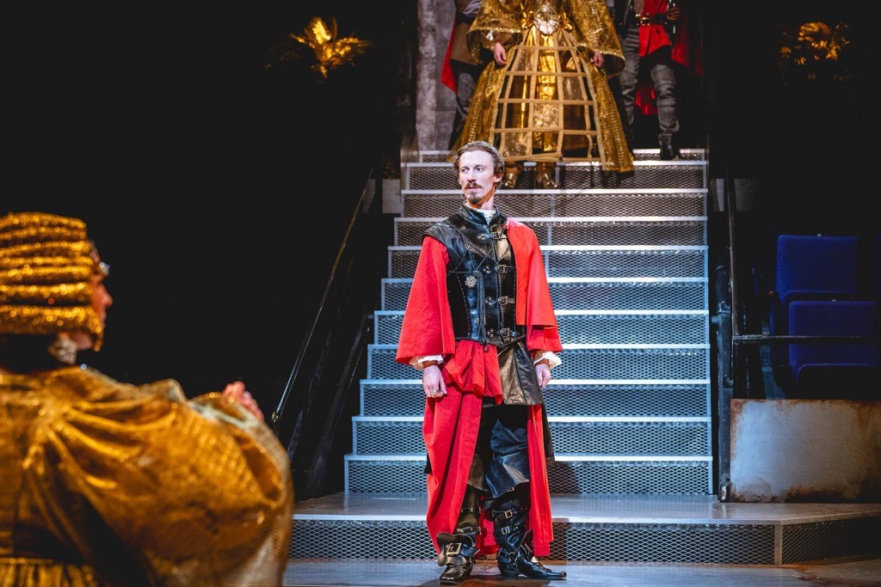
Meanwhile, the Cardinal presents the King with a new treaty to sign. The King spills ink all over his hand, and the Queen calls Constance to clean it up. However, it is Milady in disguise as Constance who enters. The King complains about being bored and proposes a golden masquerade ball to entertain himself. He tells the Queen she must wear the diamond necklace.

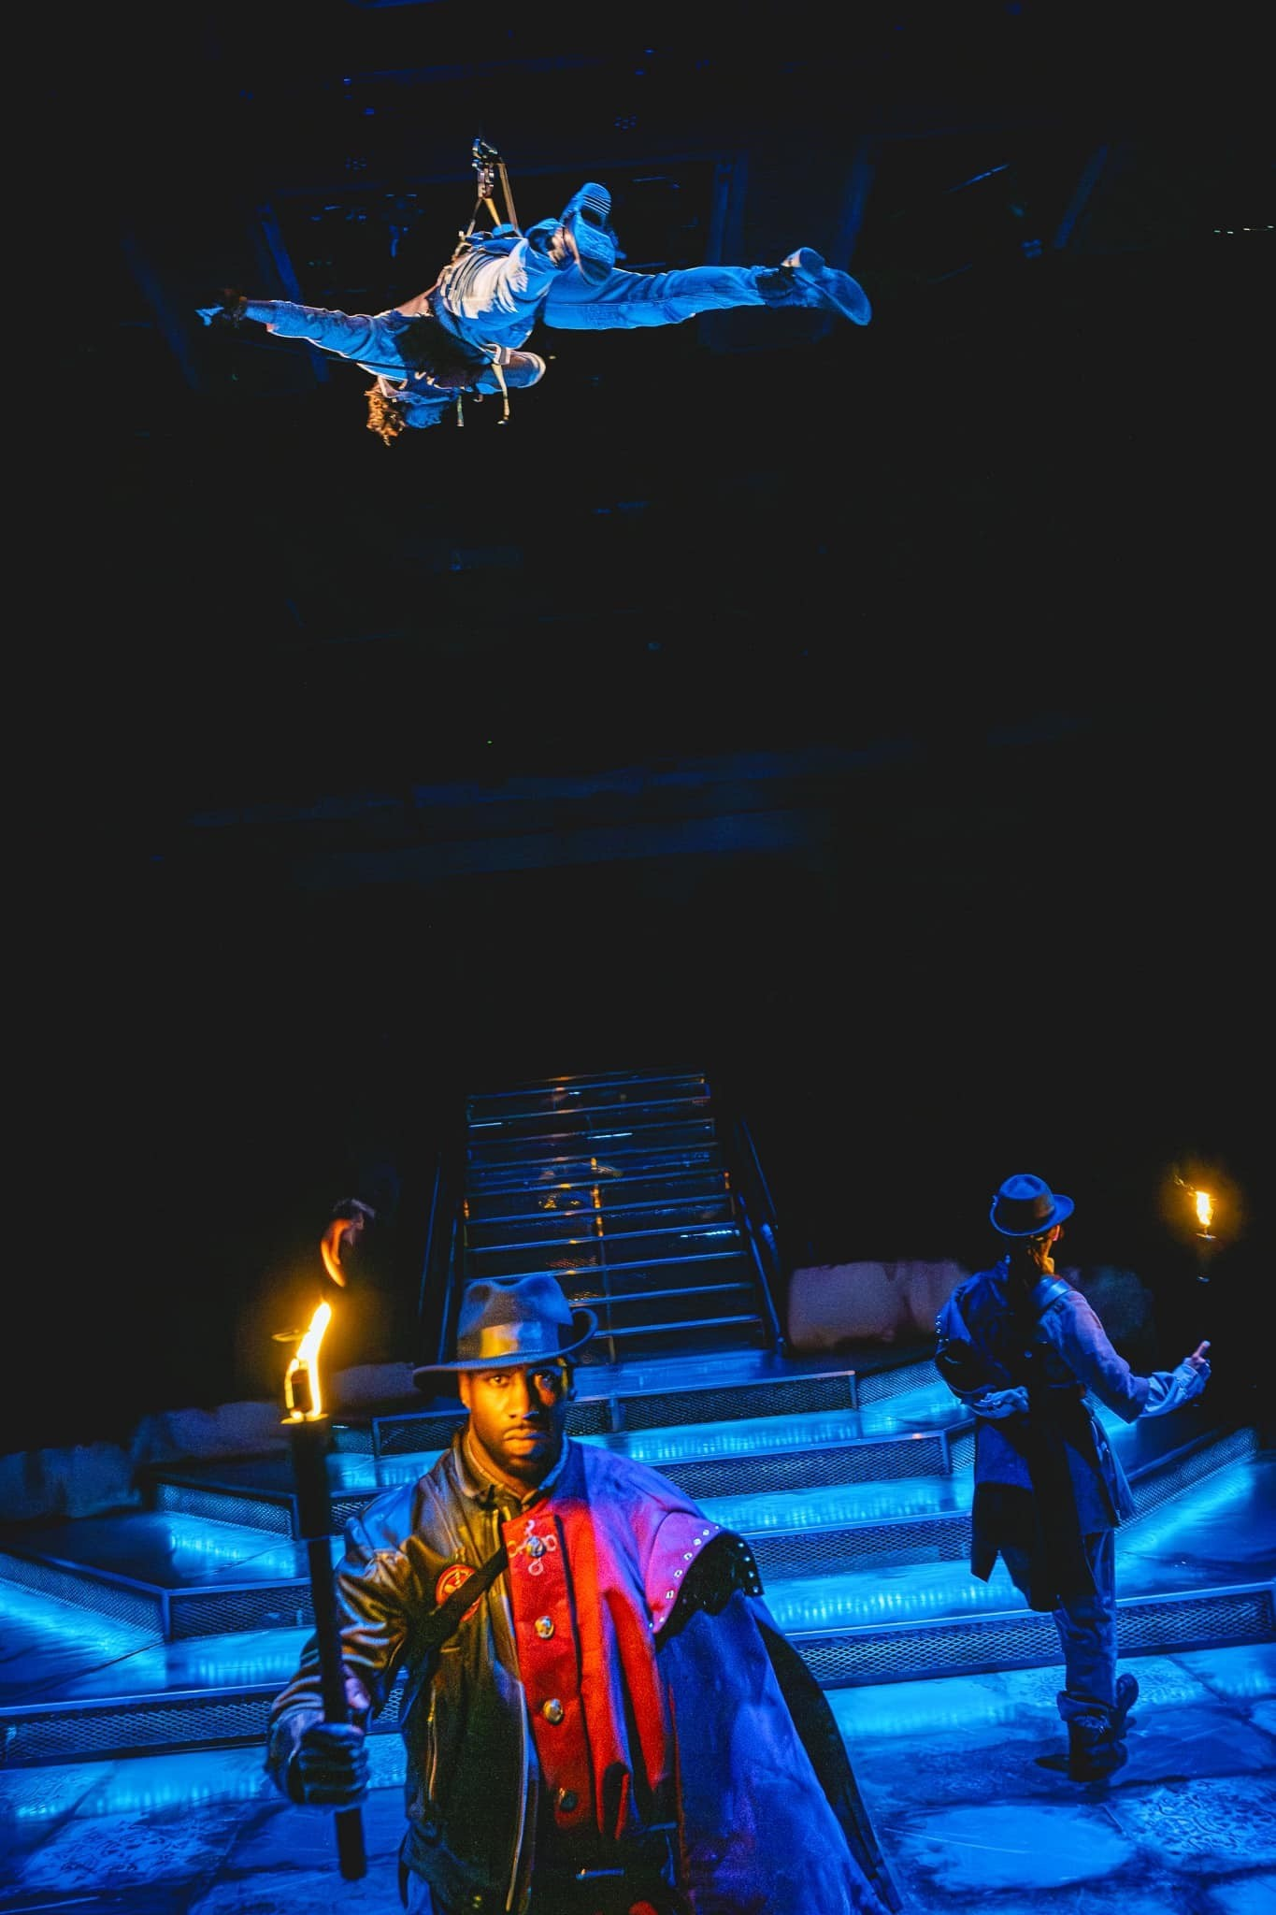
Plot Summary Act 2 continued…
After he has exited, the Queen tells Milady, who she thinks is Constance, that she still hasn’t found the necklace. She calls the dressmakers to help her choose a costume for the ball. One of them is Aramis in disguise.
As the City Guard patrol, Porthos sneaks out a manhole from the sewers – he’s covered in slime! Aramis appears and they decide to dance, D’Artagnan and Athos. As they exit, D’Artagnan abseils mission impossible style from the roof.
The next scene is the gold masquerade ball. The King passes a new law that puts the cardinal in charge of everything. As a huge disco vogue routine takes place, D’Artagnan and Porthos realise that Milady is there disguised as Constance. They lose track of her in the dancing. The Cardinal invites the Queen to dance, and they perform a tango. As he distracts her, Milady changes her disguise to look like the Queen and pours some poison into a goblet which she takes to the King. She reveals the diamond necklace as part of her plot to convince him she is the Queen.
As the King is about to drink, Athos enters and appeals to the King for mercy. Constance, who had been kidnapped, arrives and explains that she had put the necklace back in the safe. Aramis bursts out a plant pot and he explains that Milady is an imposter. The Cardinal turns on her and accuses her of stealing the necklace. He demands that she is arrested, along with the Musketeers.
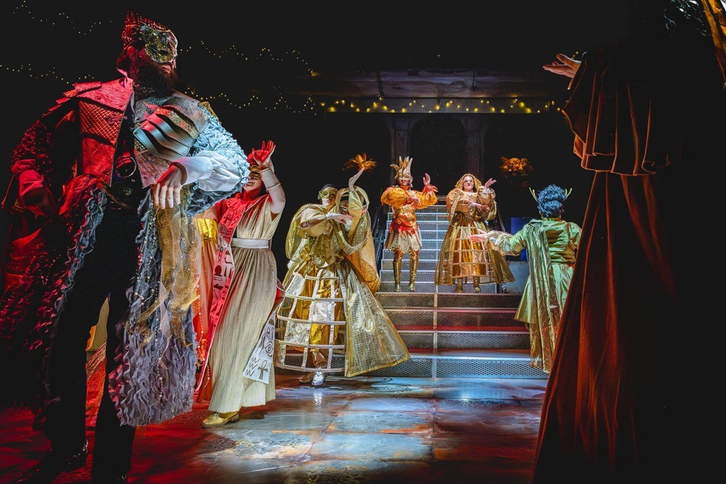
A big fight ensues – it ends with the Musketeers saving the Cardinal from Milady. Milady tries to escape and duels with D’Artagnan, who disarms her. She is escorted out to prison. The King sacks the Captain and reinstates the Musketeers as the Royal Guard.
In the final scene the Musketeers rewind the events of the play and work out that the Cardinal was behind it all. They decide to travel to Athos’s chateau in the North and ponder what to do about the Cardinal. D’Artagnan is promoted to become the fourth Musketeer.

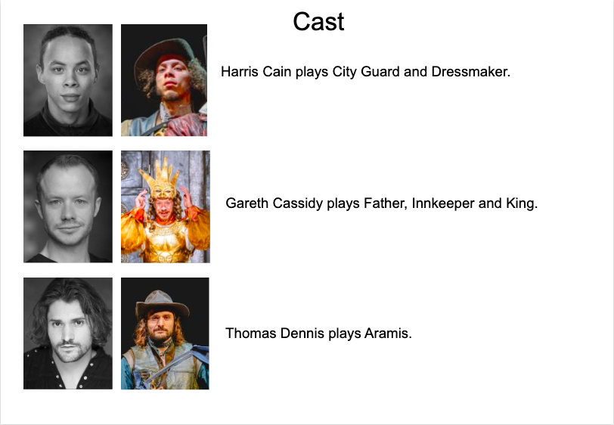
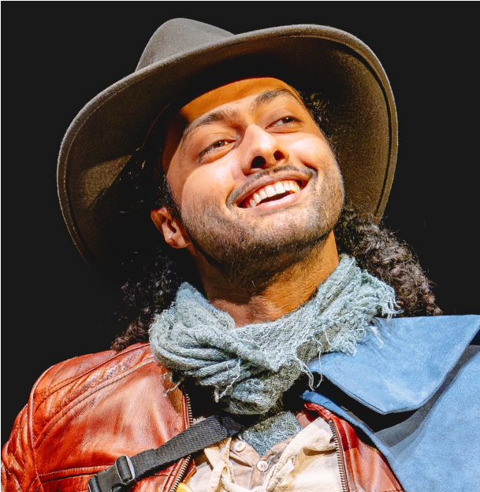 Lemar Moller plays D’Artagnan.
Perry Moore plays the Cardinal.



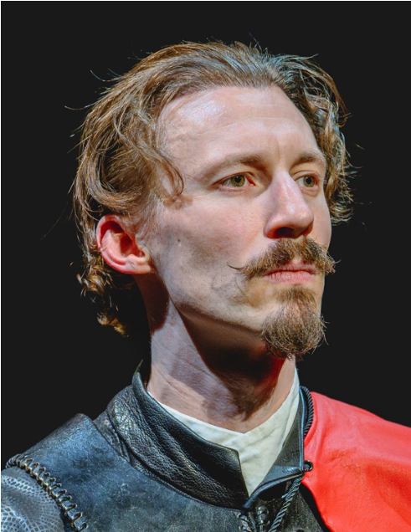
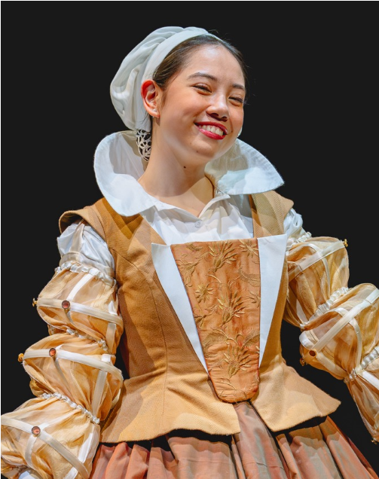
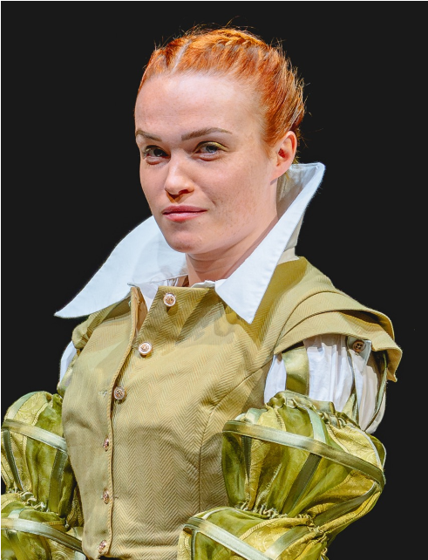
Charlotte Price plays Milady.
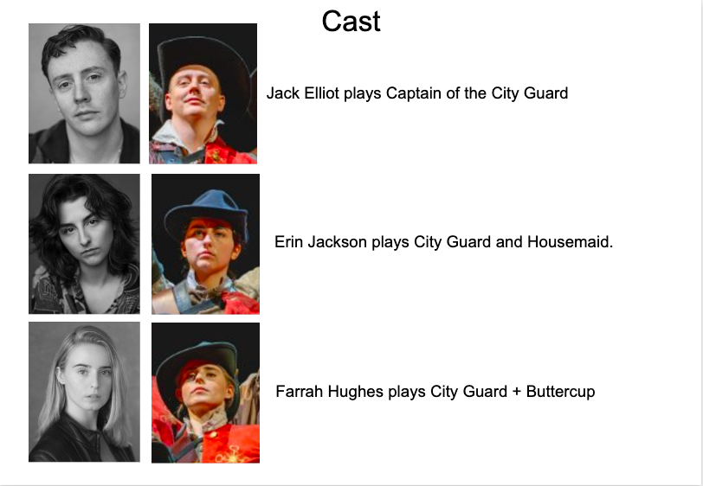
Chloe Ragrag plays Constance.
 Louis J. Rhone plays Athos.
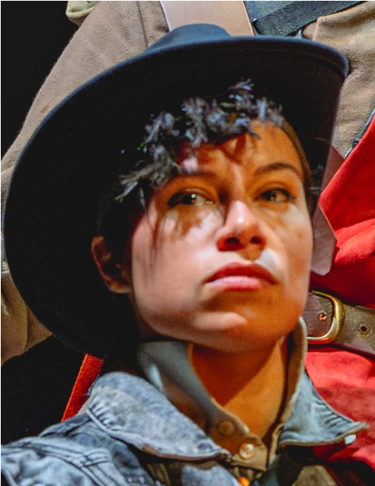 Rhiannon Skerritt plays City Guard and Dressmaker.
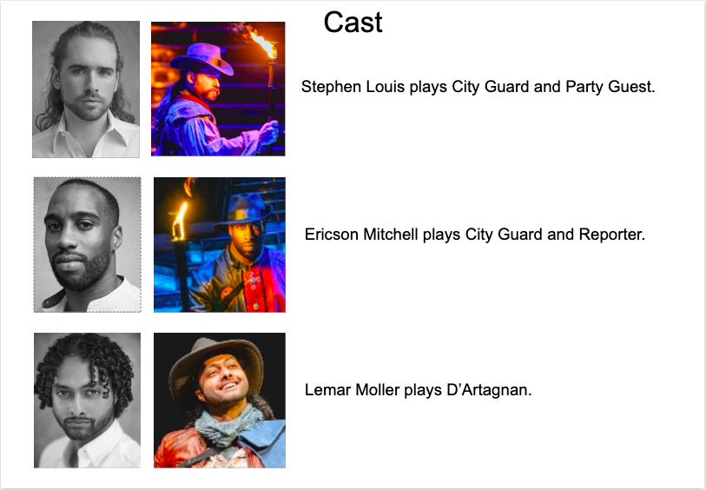
 Hadley Smith plays Porthos. 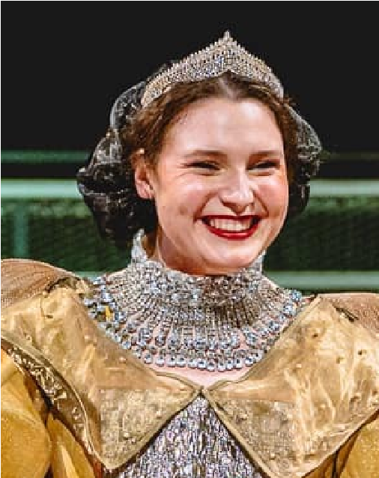 Emma Symmonds plays Queen.

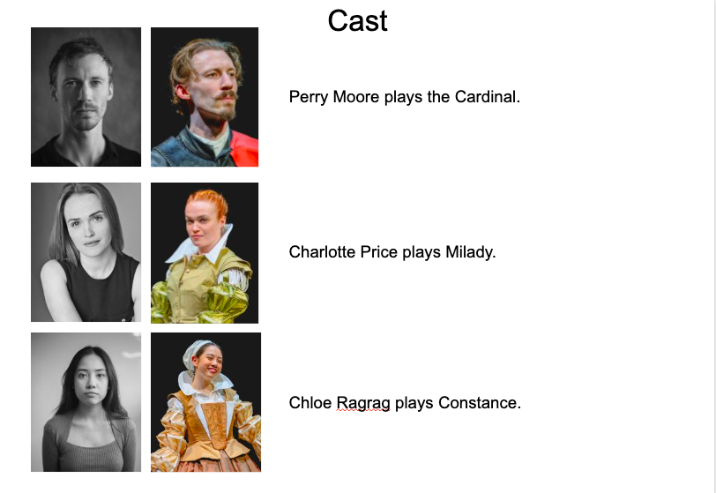

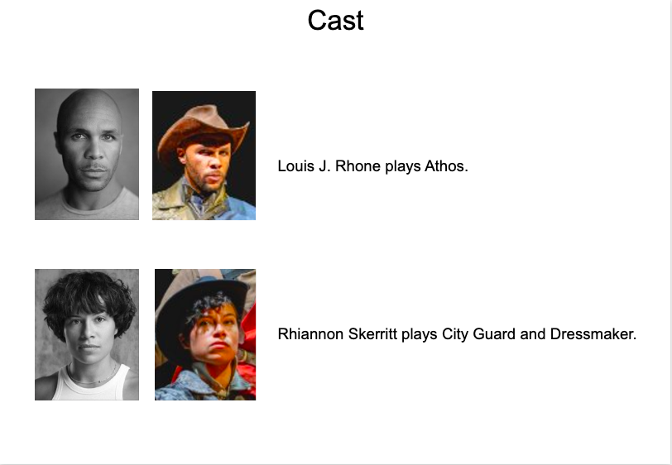


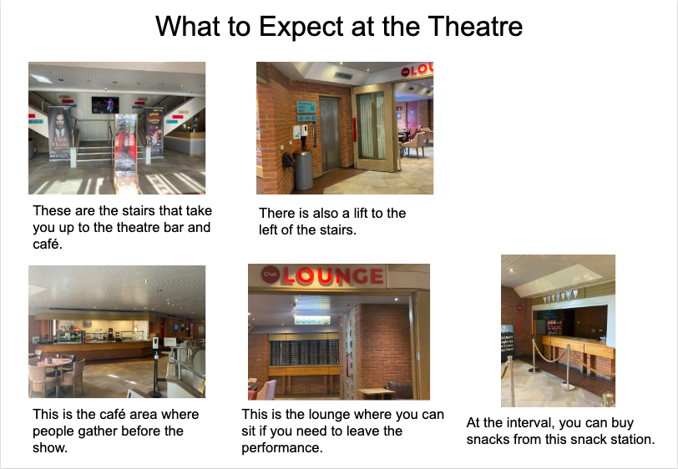



For More Information contact us at Box Office:
01782 717962

10:00am – 6:00pm Monday – Saturday
tickets@newvictheatre.org.uk
Accessible performances:

Audio Described Performances
Saturday 21 December 2.15pm Saturday 18 January 2.15pm

Captioned Performances
Saturday 11 January 2.15pm
Saturday 18 January 7.30pm
Relaxed Performance
Saturday 11 January 2.15pm

For more information visit: https://www.newvictheatre.org.uk/your-visit/access/

